Chase Brown

3.25.17 Python Port Scanner GUI

First Window

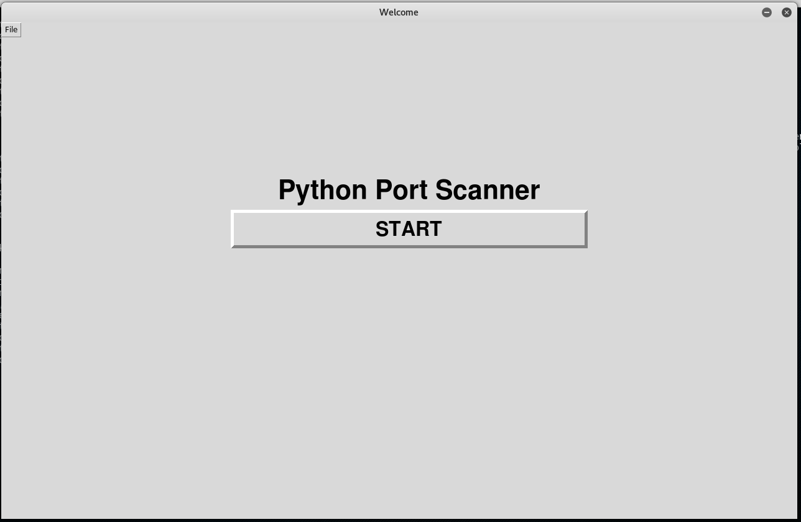

Menu in top left with about and exit program

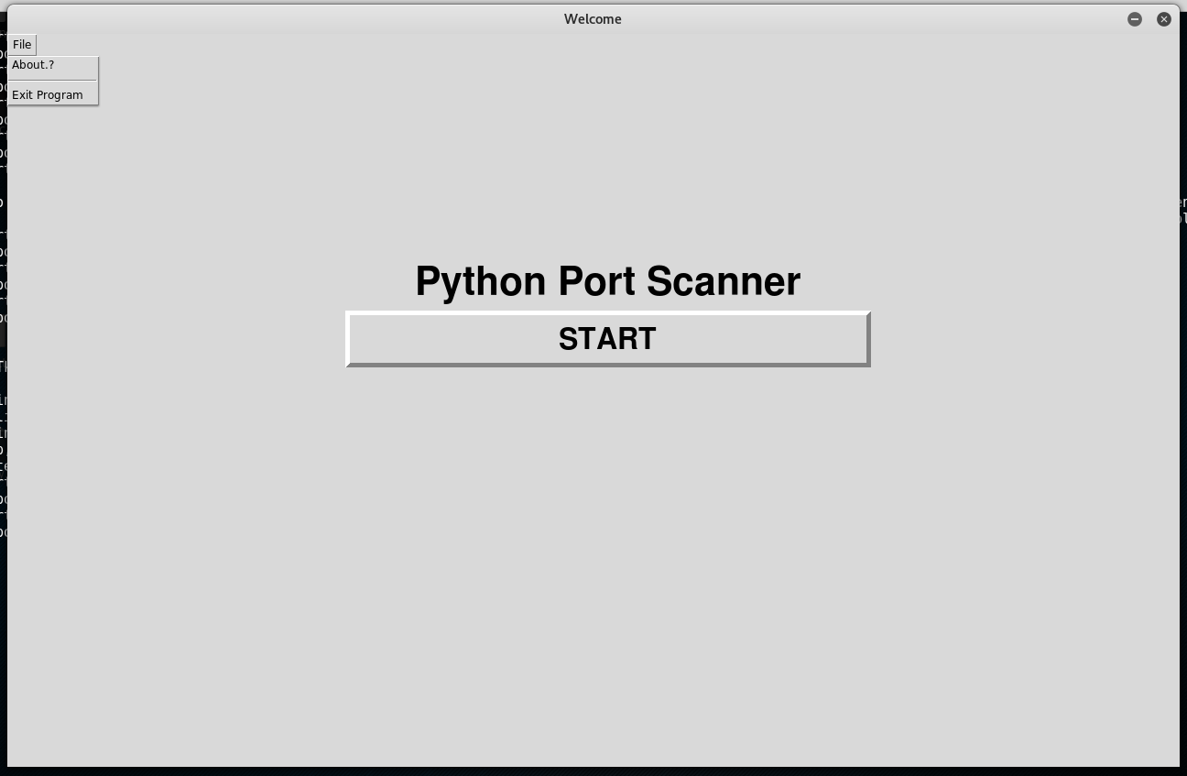

Pop up message when about is selected form File menu

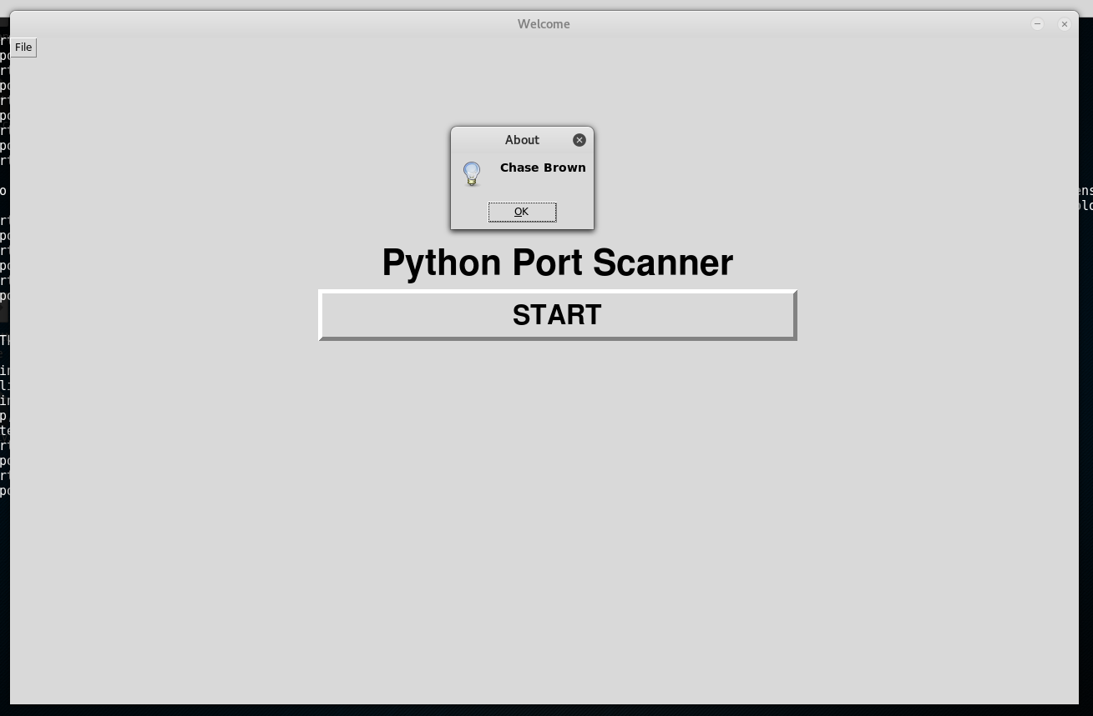

Main menu window when you click the START button from the Welcome

New menu added to top left for help with scanner

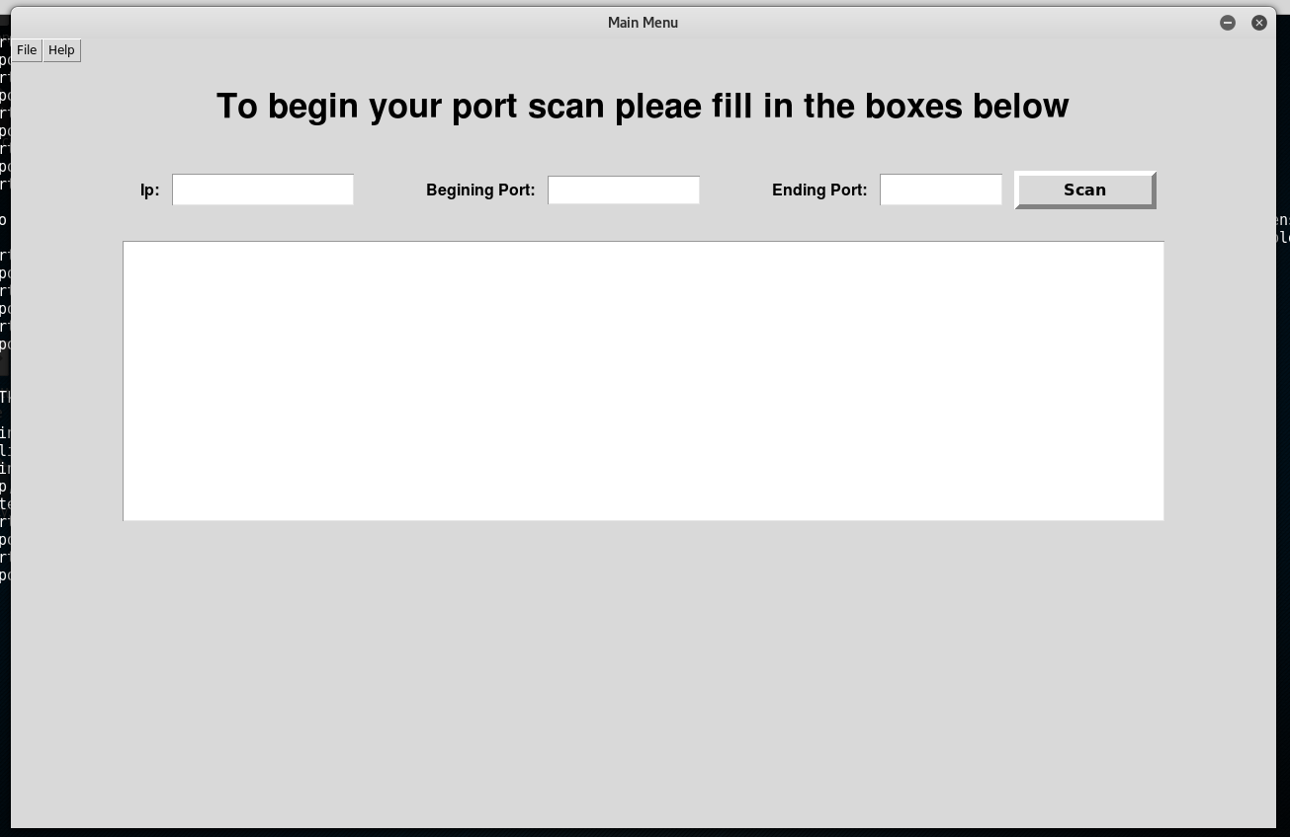

Pop up when Help menu is selected with examples for input

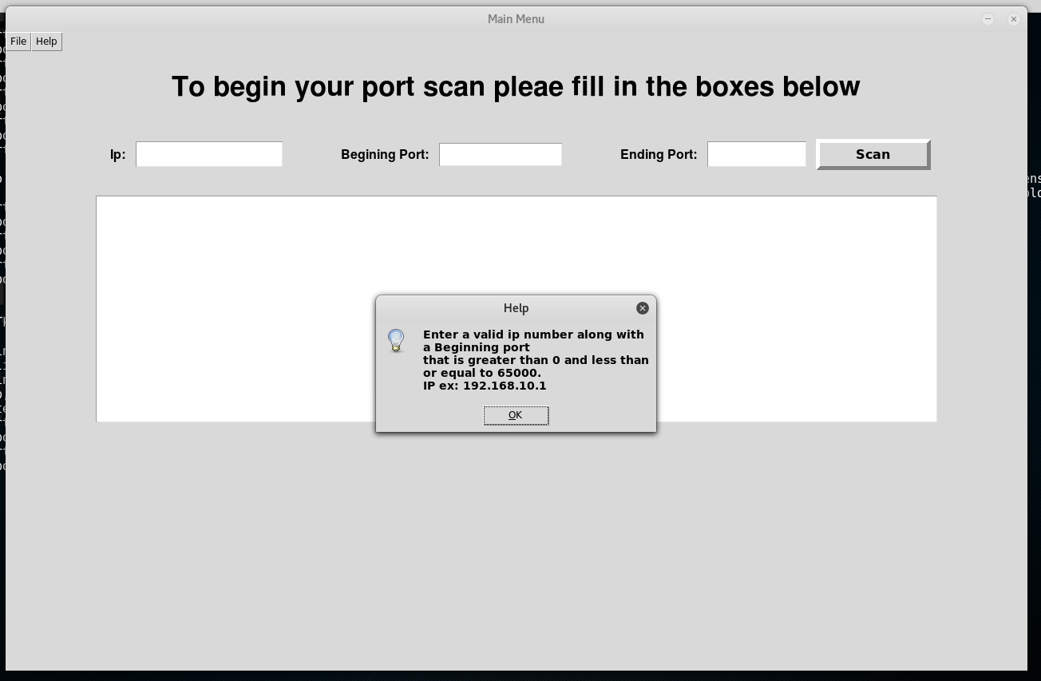

Example of input

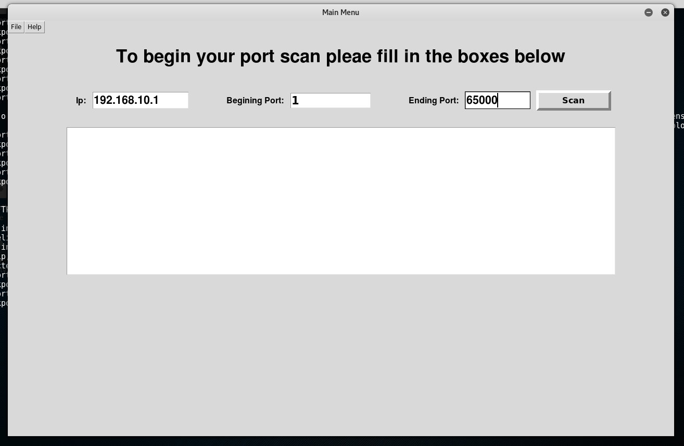

Example of output

